**Write a Python Program to perform brute force attack on the cipher text “dvvkzecfssprkkve"**

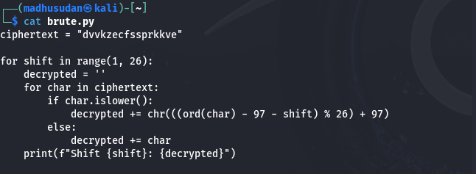

**Output**

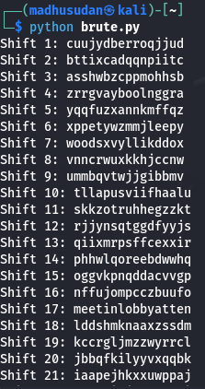

**2. Write a Python program to use brute force attack to decipher the message.**

**Assume Affine cipher was used and "ab" is encrypted as "GL". Find the value of keys.**

**XPALASXYFGFUKPXUSOGEUTKCDGFXANMGNVS**

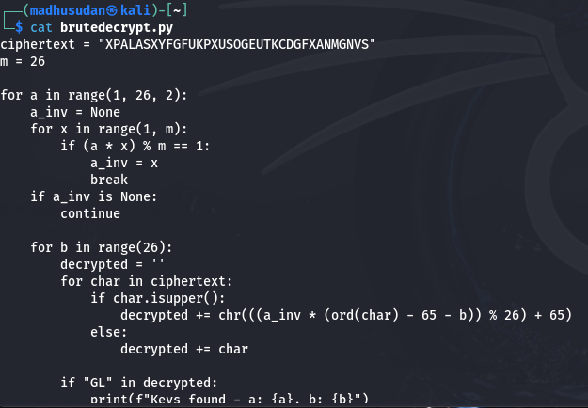

**output**

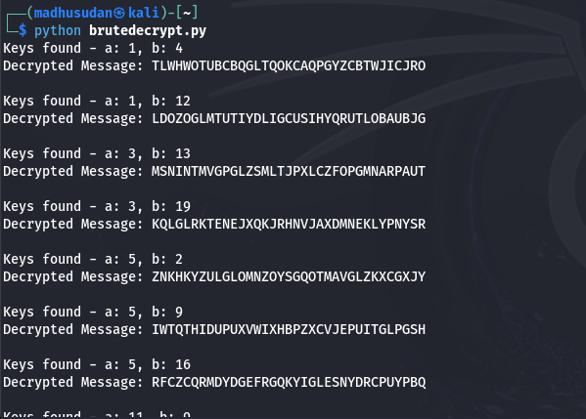

**3.Encrypt the plain text using Rail Fence cipher**

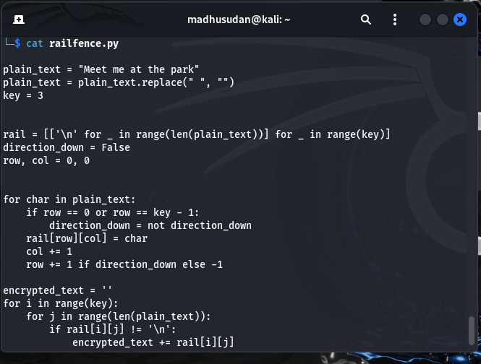

**Output**

